**Exercise 1: Control Structures**

**Scenario 1:** The bank wants to apply a discount to loan interest rates for customers above 60 years old.

**Question:** Write a PL/SQL block that loops through all customers, checks their age, and if they are above 60, apply a 1% discount to their current loan interest rates.

**STEP 1: First create customers and loans tables and insert values in them.**

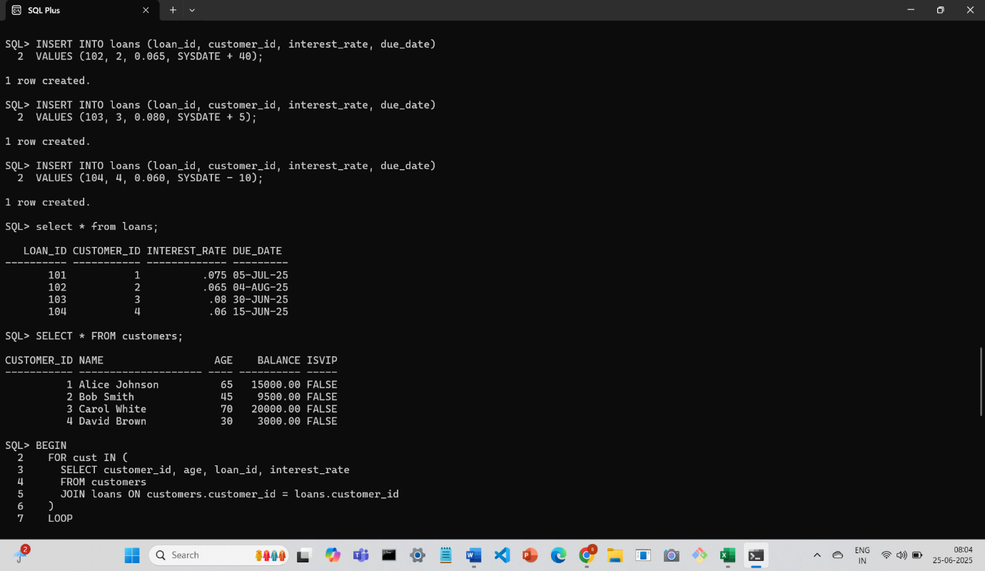

**STEP 2: Write a PL/SQL block that loops through all the customers , checks their age,and if they are above 60,apply a 1% discount to their current loan interest rates**

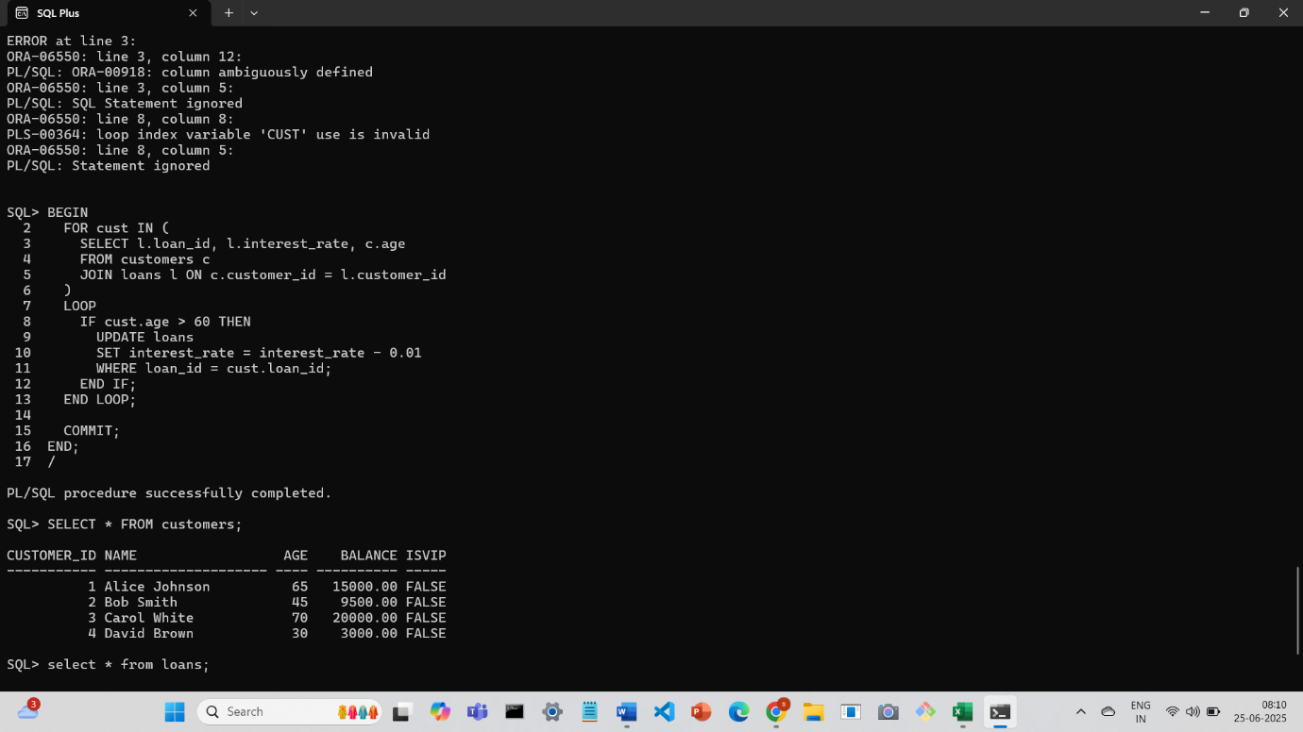

**STEP 3: Output after 1% discount is applied**

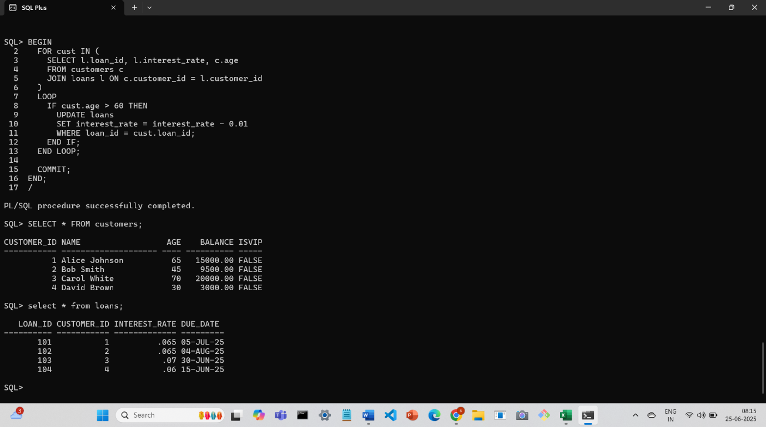

**Scenario 2:** A customer can be promoted to VIP status based on their balance.

**Question:** Write a PL/SQL block that iterates through all customers and sets a flag IsVIP to TRUE for those with a balance over $10,000.

**STEP 1: customers and loans table before applying PL/SQL block**

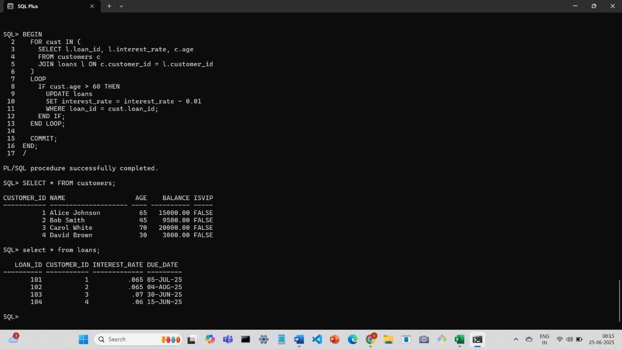

**STEP 2: PL/SQL block that sets a flag ISVIP to true if balance is over $10000 for all customers**

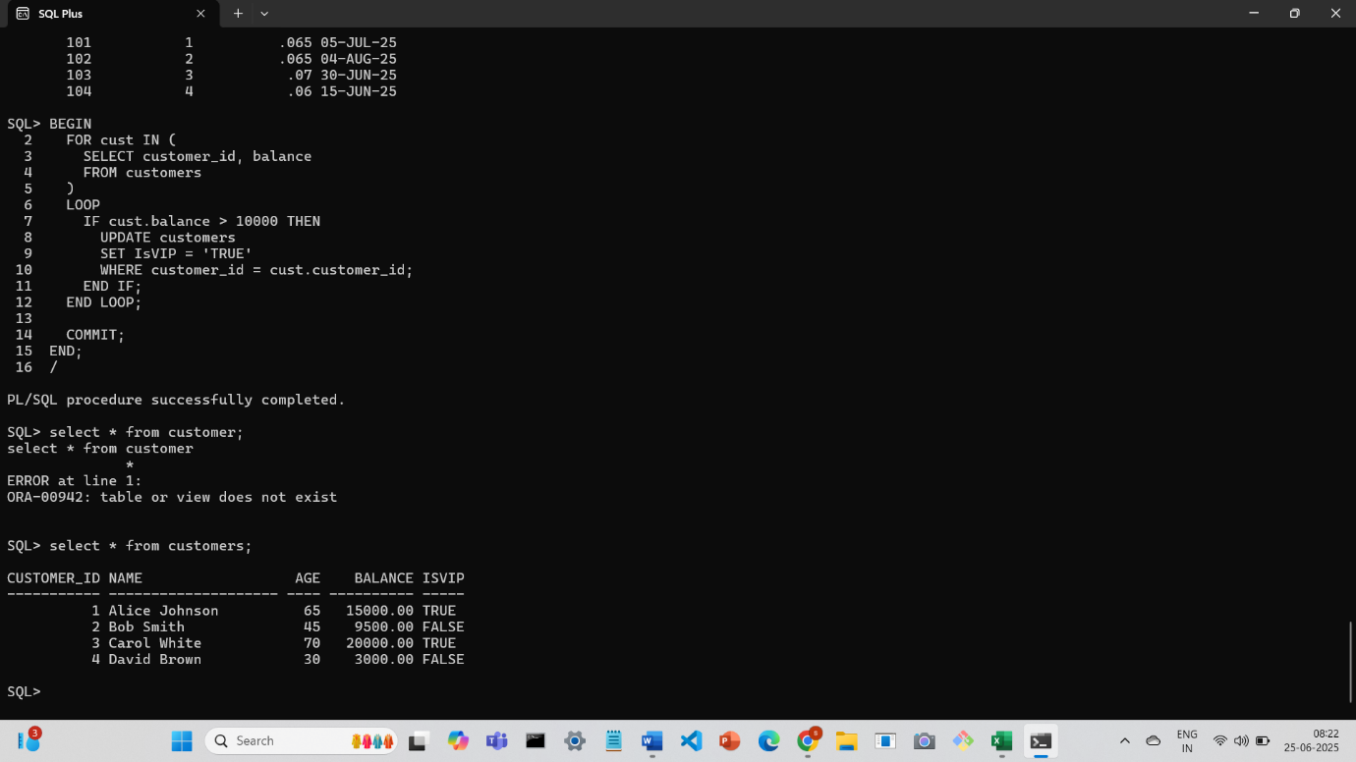

**STEP 3: Output after PL/SQL block**

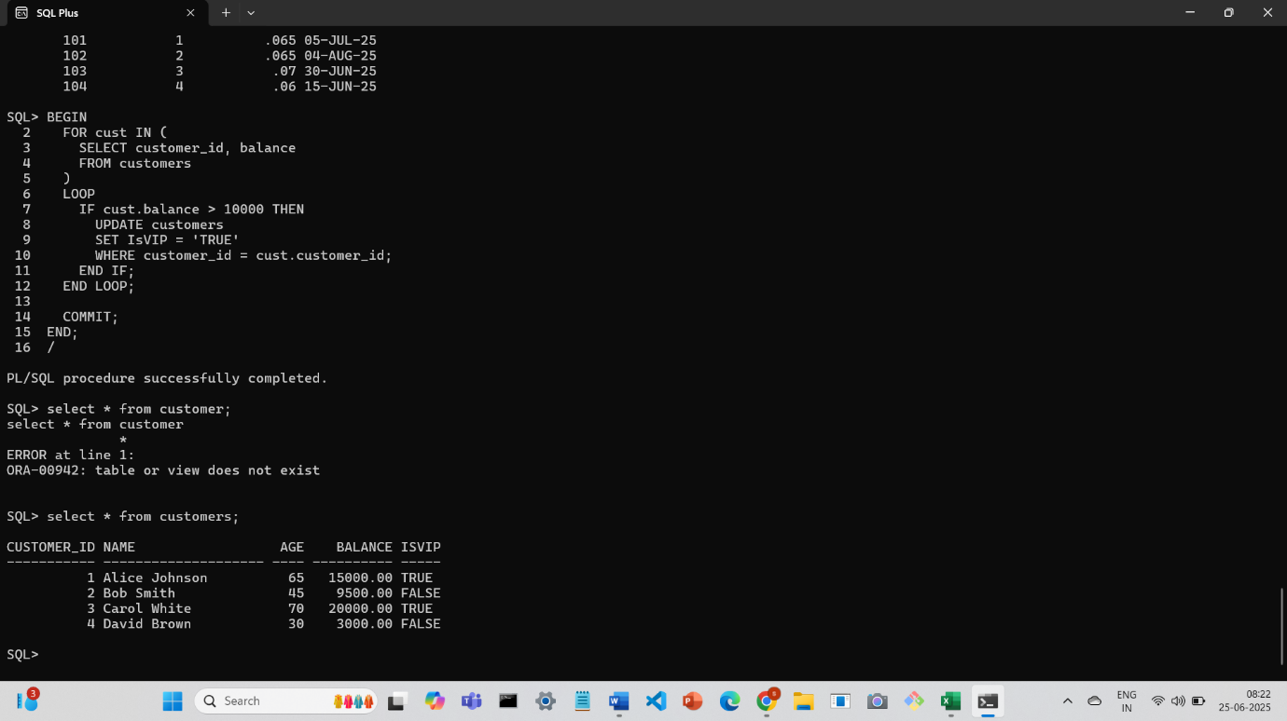

**Scenario 3:** The bank wants to send reminders to customers whose loans are due within the next 30 days.

**Question:** Write a PL/SQL block that fetches all loans due in the next 30 days and prints a reminder message for each customer.

**STEP 1: PL/SQL block to print remainder message**